WIKI REPORT

A)How to import required libraries and perform Sentimental analysis task on the given data using one of the Deep Learning Classifier(Keras model)for text and also performing Data cleaning and preprocessing like removing unnecessary Columns or Data,Removing Twitter Handles( @user ), Removing punctuation, numbers, special characters, Removing stop words, Tokenizing, and Stemming, TFIDF vectors, POS tagging, checking for missing values ,train/test split of data.

B)Imported the required libraries for performing sentimental analysis tasks on the given data set. I have used libraries like import pandas as pd

import numpy as np

import re

import string

import keras

import nltk

from nltk import sent_tokenize

from nltk import word_tokenize

from numpy import arrays

from keras.models import Sequential

from keras.layers.core import Activation,Dropout,Dense

from sklearn.model_selection import train_test_split

from keras.preprocessing.text

import Tokenizer plotting libraries

from matplotlib import pyplot as plt

import seaborn as sns

import nltk

import nltk

nltk.download('stopwords')

from nltk.corpus

import stopwords

#Global parameters STOPWORDS=set(stopwords.words('english')) nltk.download(“popular")

FOR DATACLEANING AND PREPROCESSING I HAVE USED SOME FUNCTIONS LIKE:

#changes in lower case

tweet.lower()

#regular expression is used to remove urls punctuations and all #removes user references and

#from tweet

tweet=re.sub(r'@\w+|#','',tweet)

#used to remove urls

tweet=re.sub(re’http\S+www\S+https\S+",'',tweet,flags=re.MULTILINE)

#used to remove punctuations tweet=tweet.translate(str.maketrans('','',string.punctuation))

#used to remove multisapces

tweet=re.sub(r'\s+',' ',tweet)

#used to remove single characters

tweet=re.sub(r'\s+[a-zA-Z]\s+',' ',tweet)

#converting in list

tweet=list(tweet.split(" "))

#to remove stop words

filtered_words=[w for w in tweet if not w in STOPWORDS]

#printing only filtered words

#removing numeric from given data sets

alpha_words=[w for w in filtered_words if w.isalpha()] return " ".join(alpha_words)

#POS TAGGING

#Tokenizing words :

tokenized_words = word_tokenize(sentence)

#Generating output for TF_IDF : X = vectorizer.fit_transform(sentences).toarray()

#TRAIN/TEST SPLIT DATA

history=model.fit(X_train,Y_train,batch_size=batch_size,epochs=epochs,verbose=1,validation_split=0.1) score=model.evaluate(X_test,Y_test,batch_size=batch_size,verbose=1)

DATA VISUALIZATION AND ANALYSIS FOR CRITICAL STEPS:

plt.plot(history.history['accuracy']) plt.plot(history.history['val_accuracy'])

plt.title('model accuracy')

plt.ylabel('accuracy')

plt.xlabel('epoch')

plt.legend(['train','validation'],loc='upper left')

plt.show()

plt.plot(history.history['loss'])

plt.plot(history.history['val_loss'])

plt.title('model loss')

plt.ylabel('loss')

plt.xlabel('epoch')

plt.legend(['train','validation'],loc='upper left')

plt.show()

C)IN TRAIN/TEST SPLIT OF DATA I have faced some problems while importing libraries and labeling

D)SCREENSHOTS:

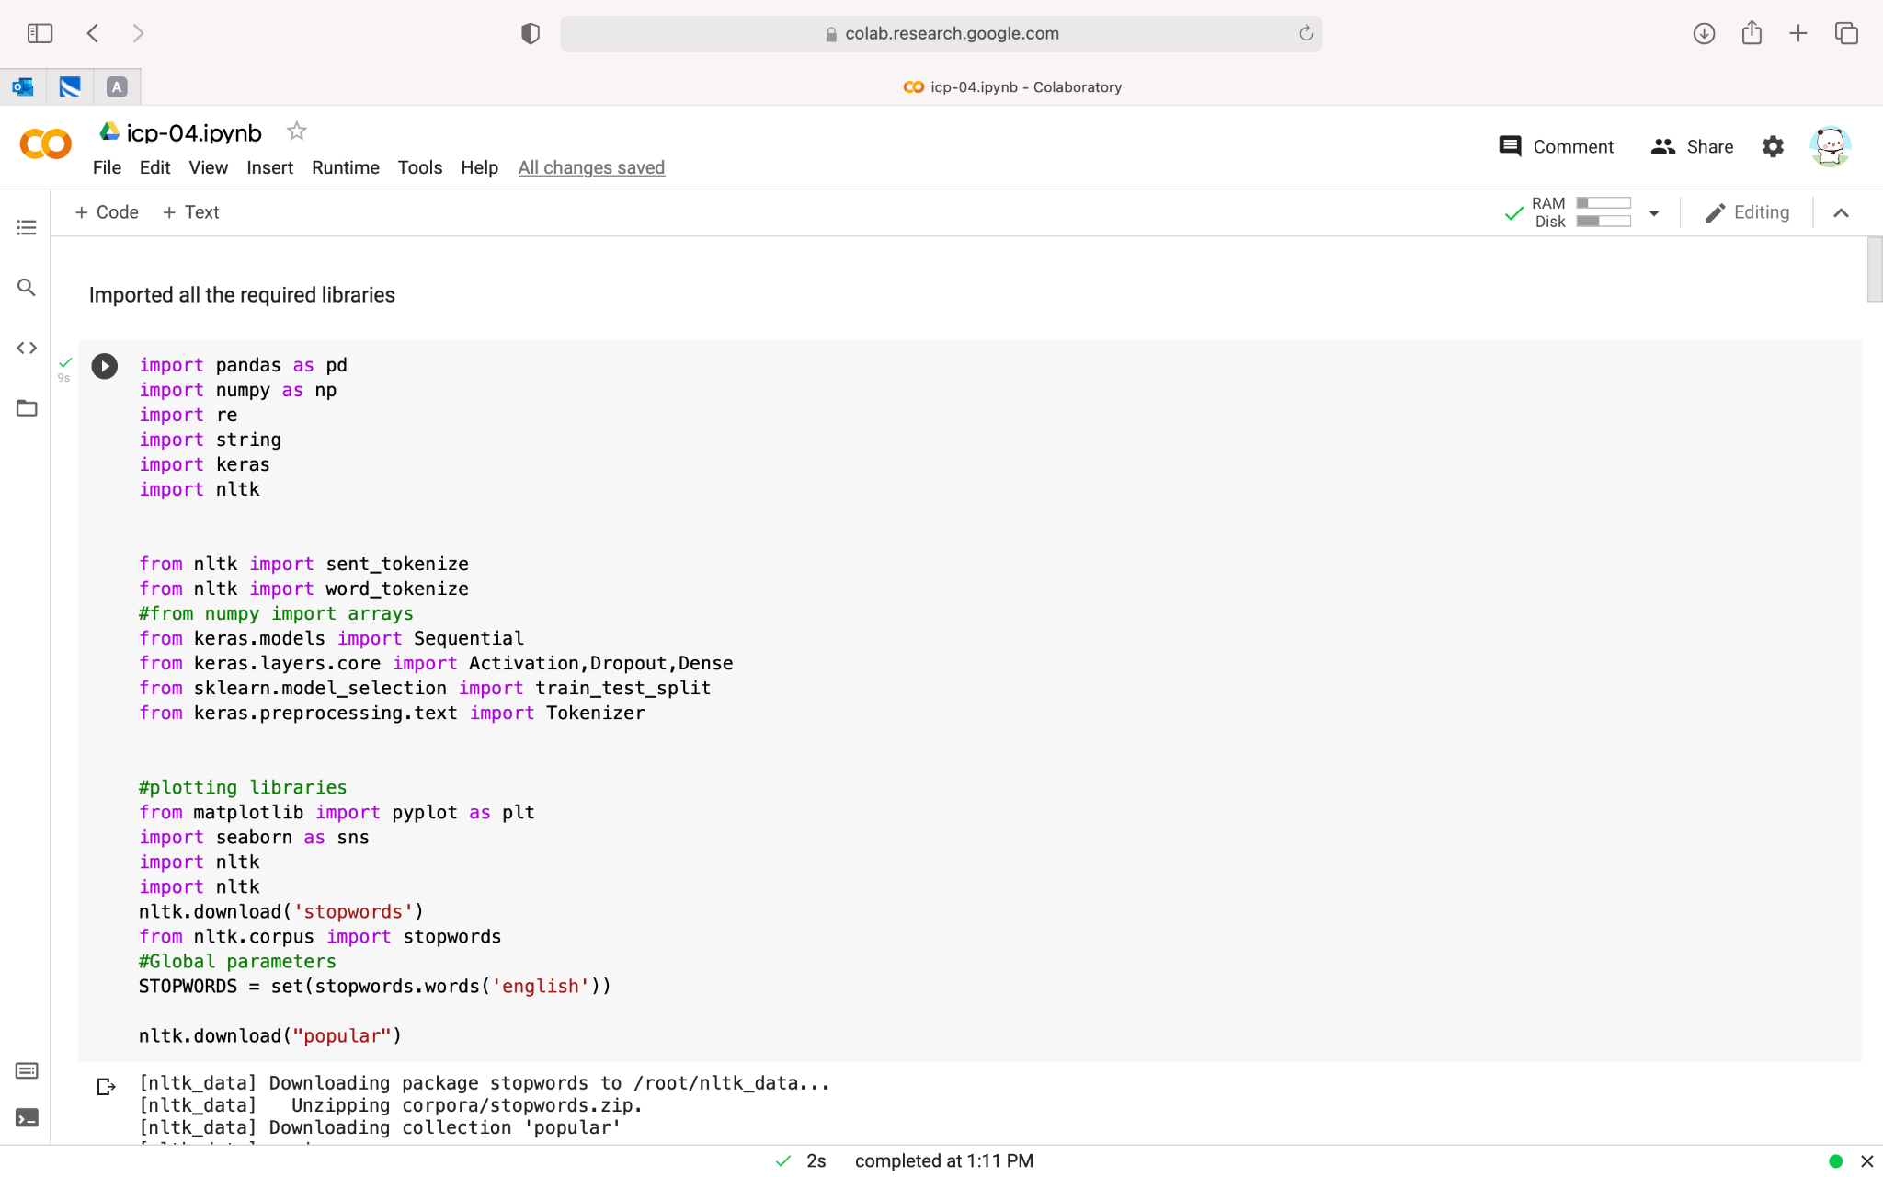

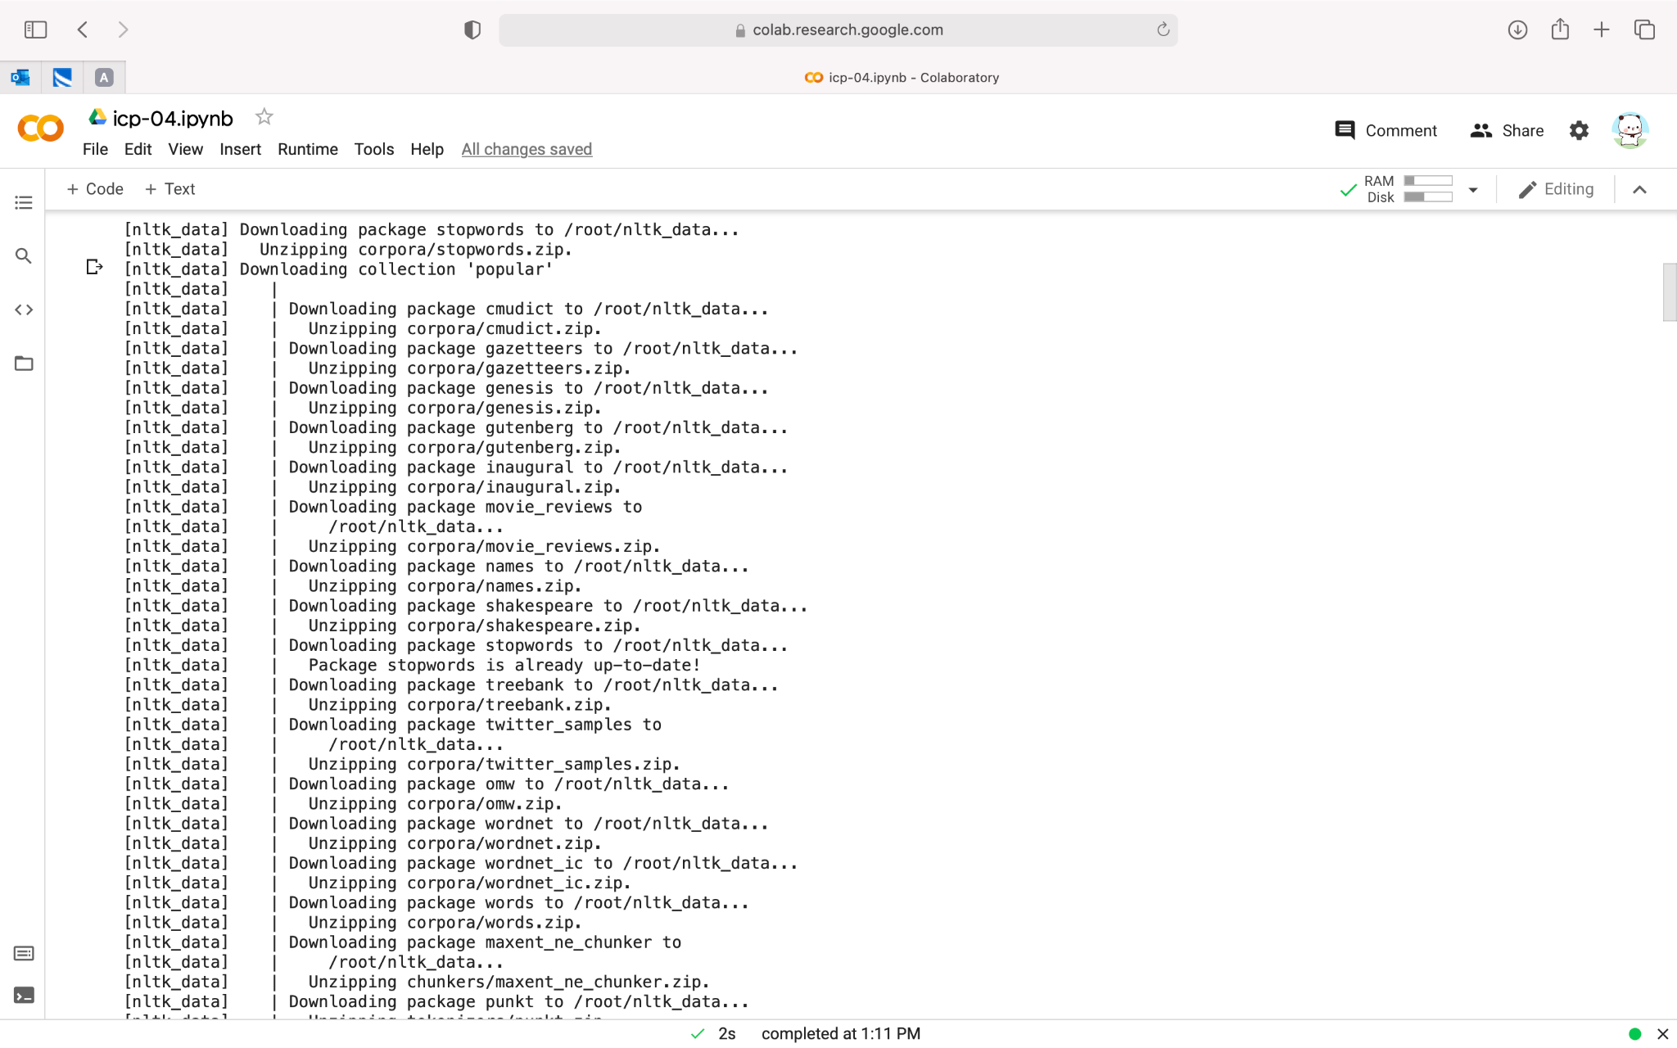

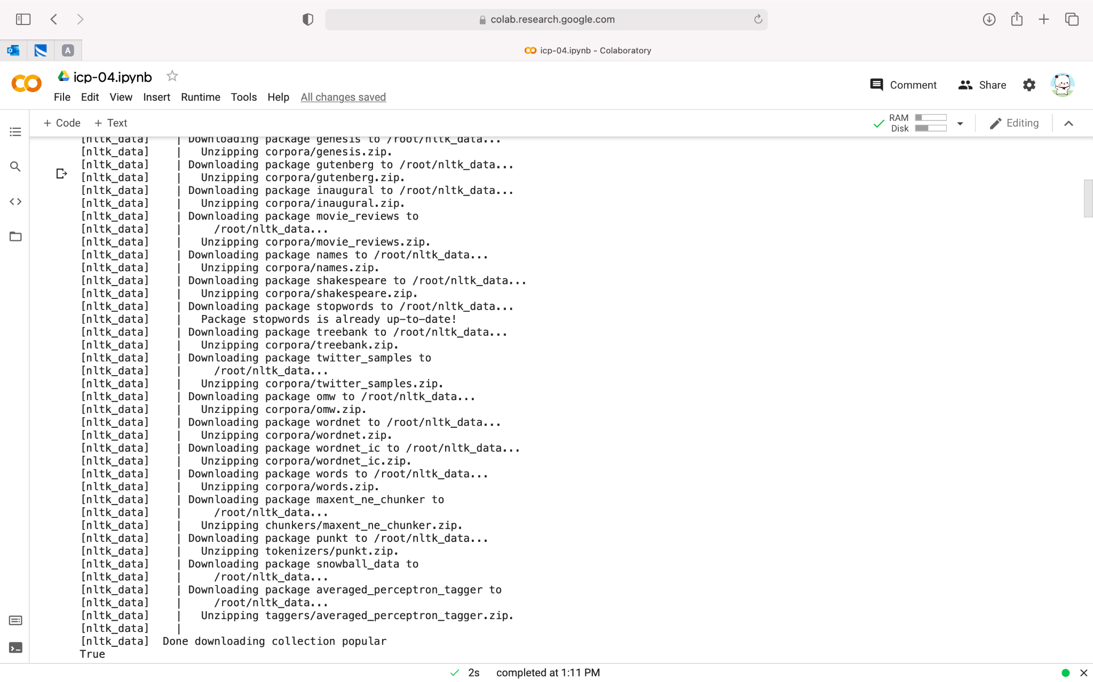

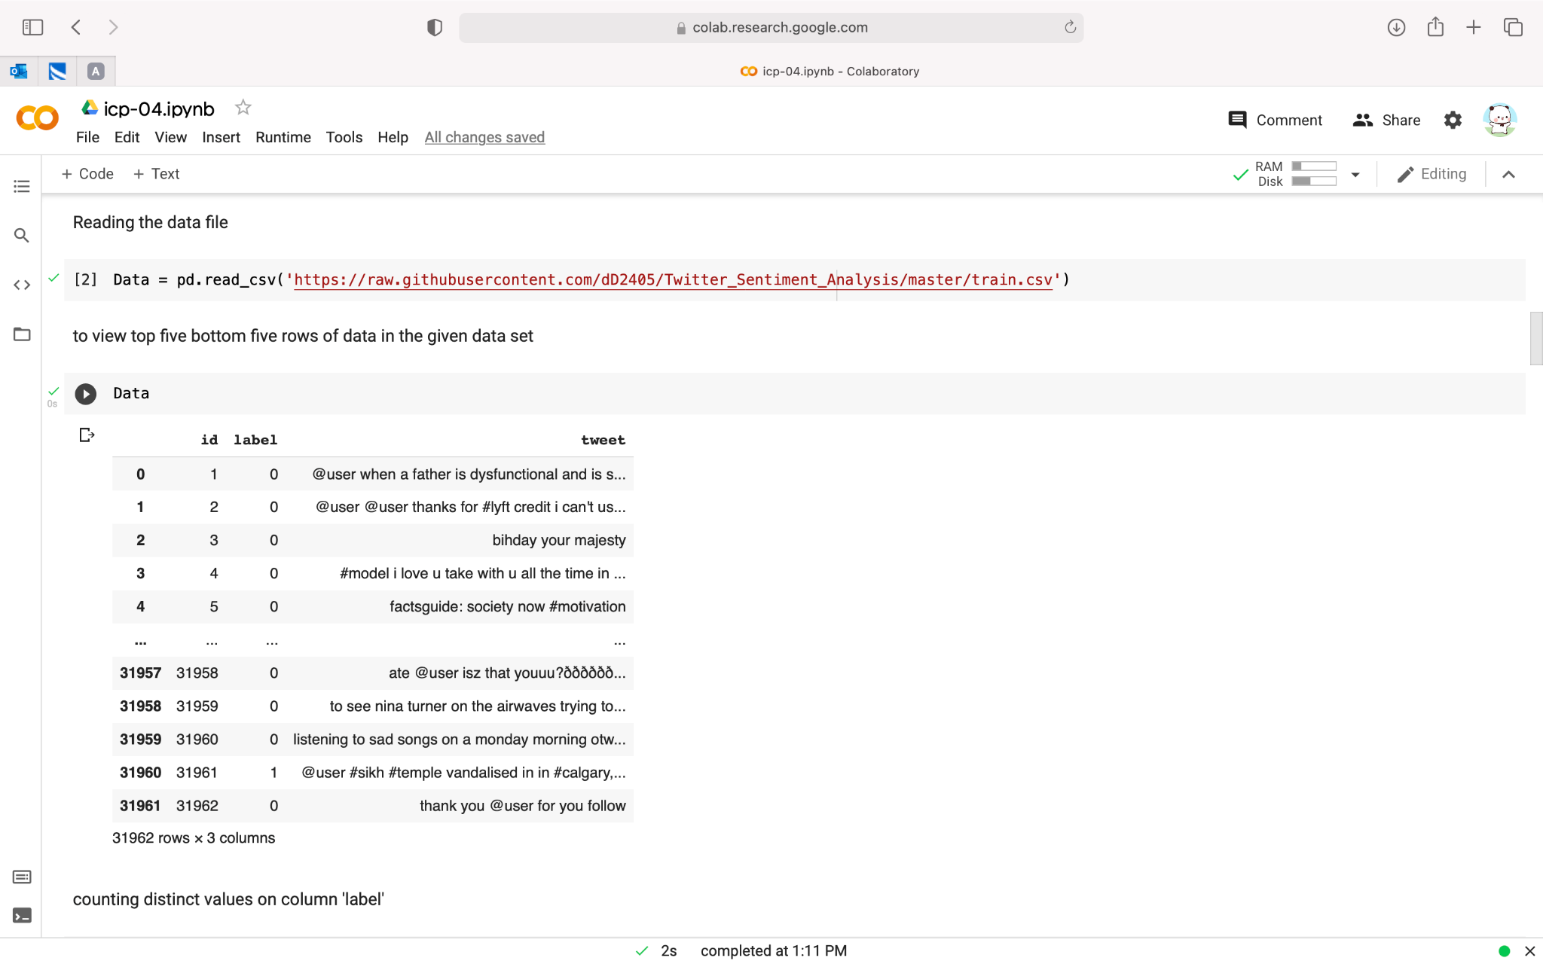

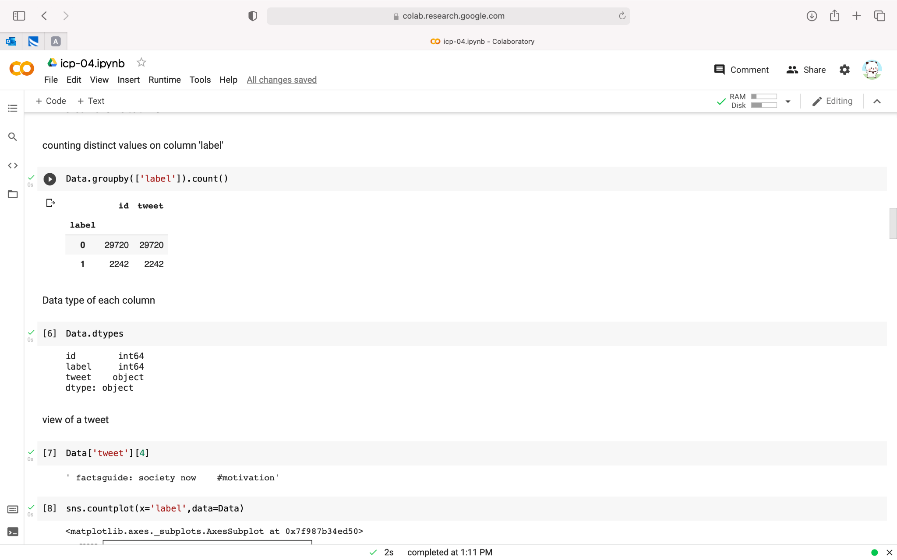

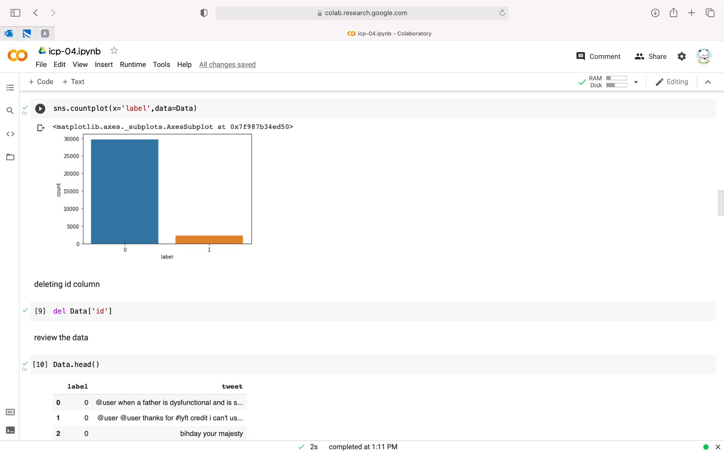

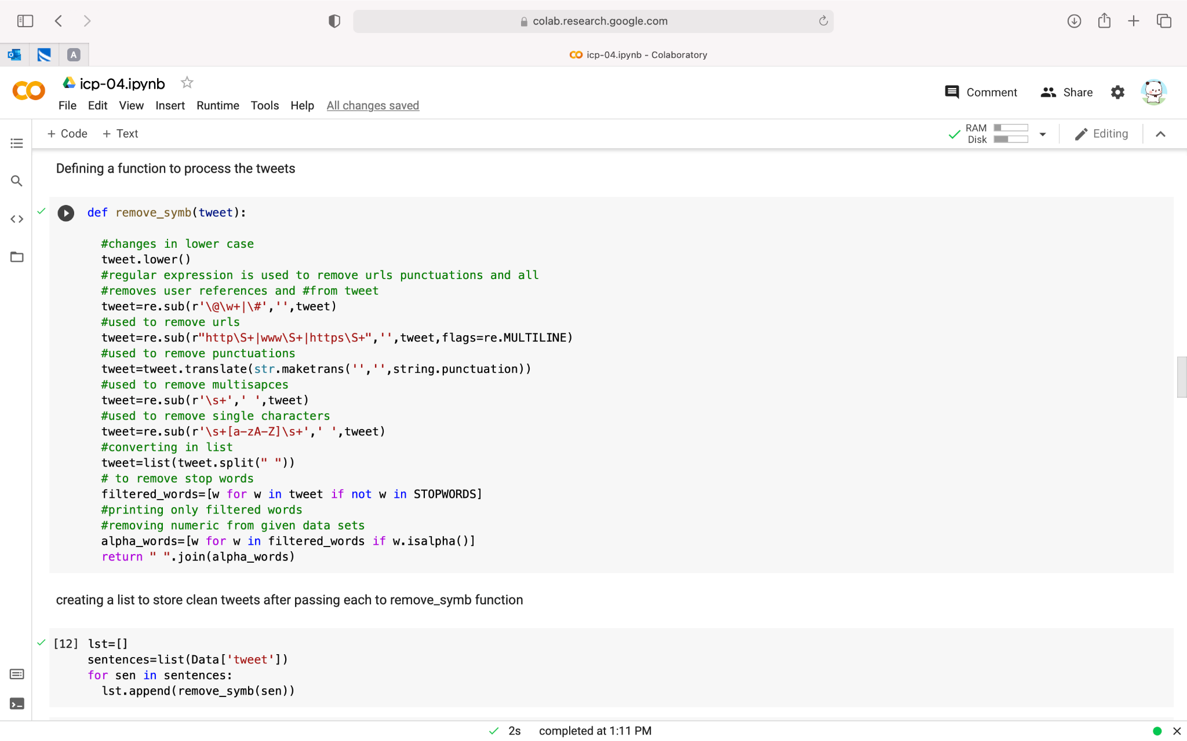

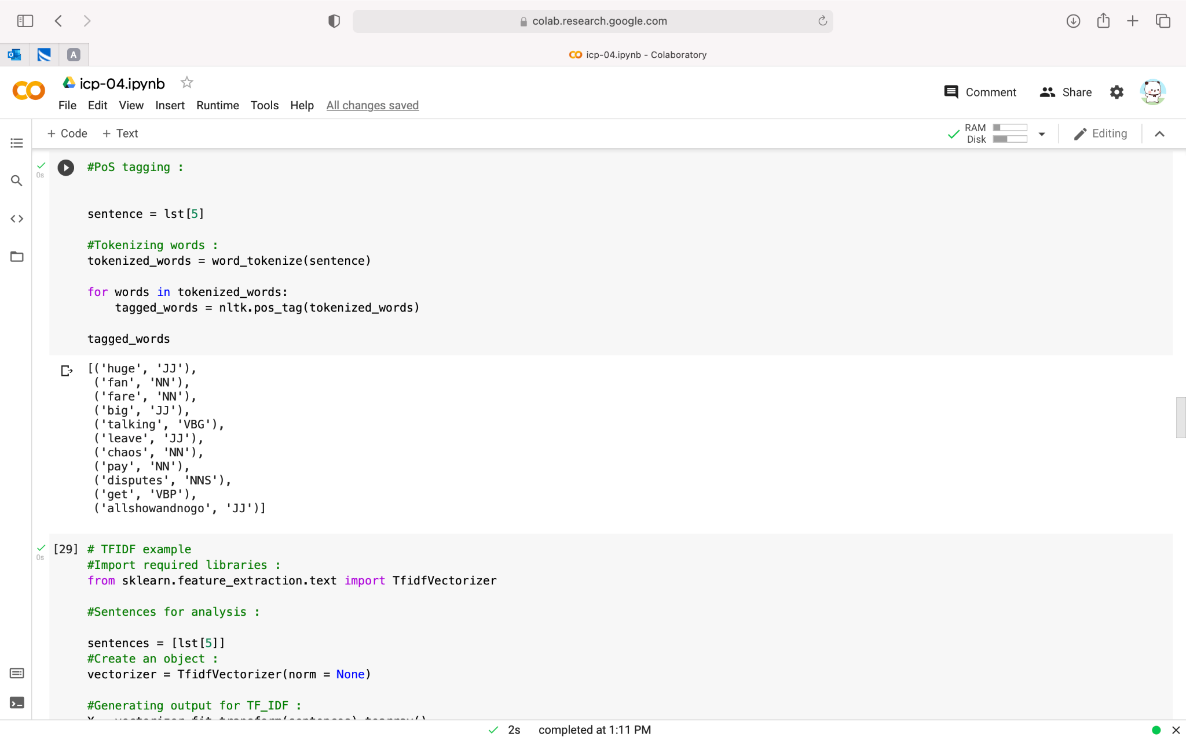

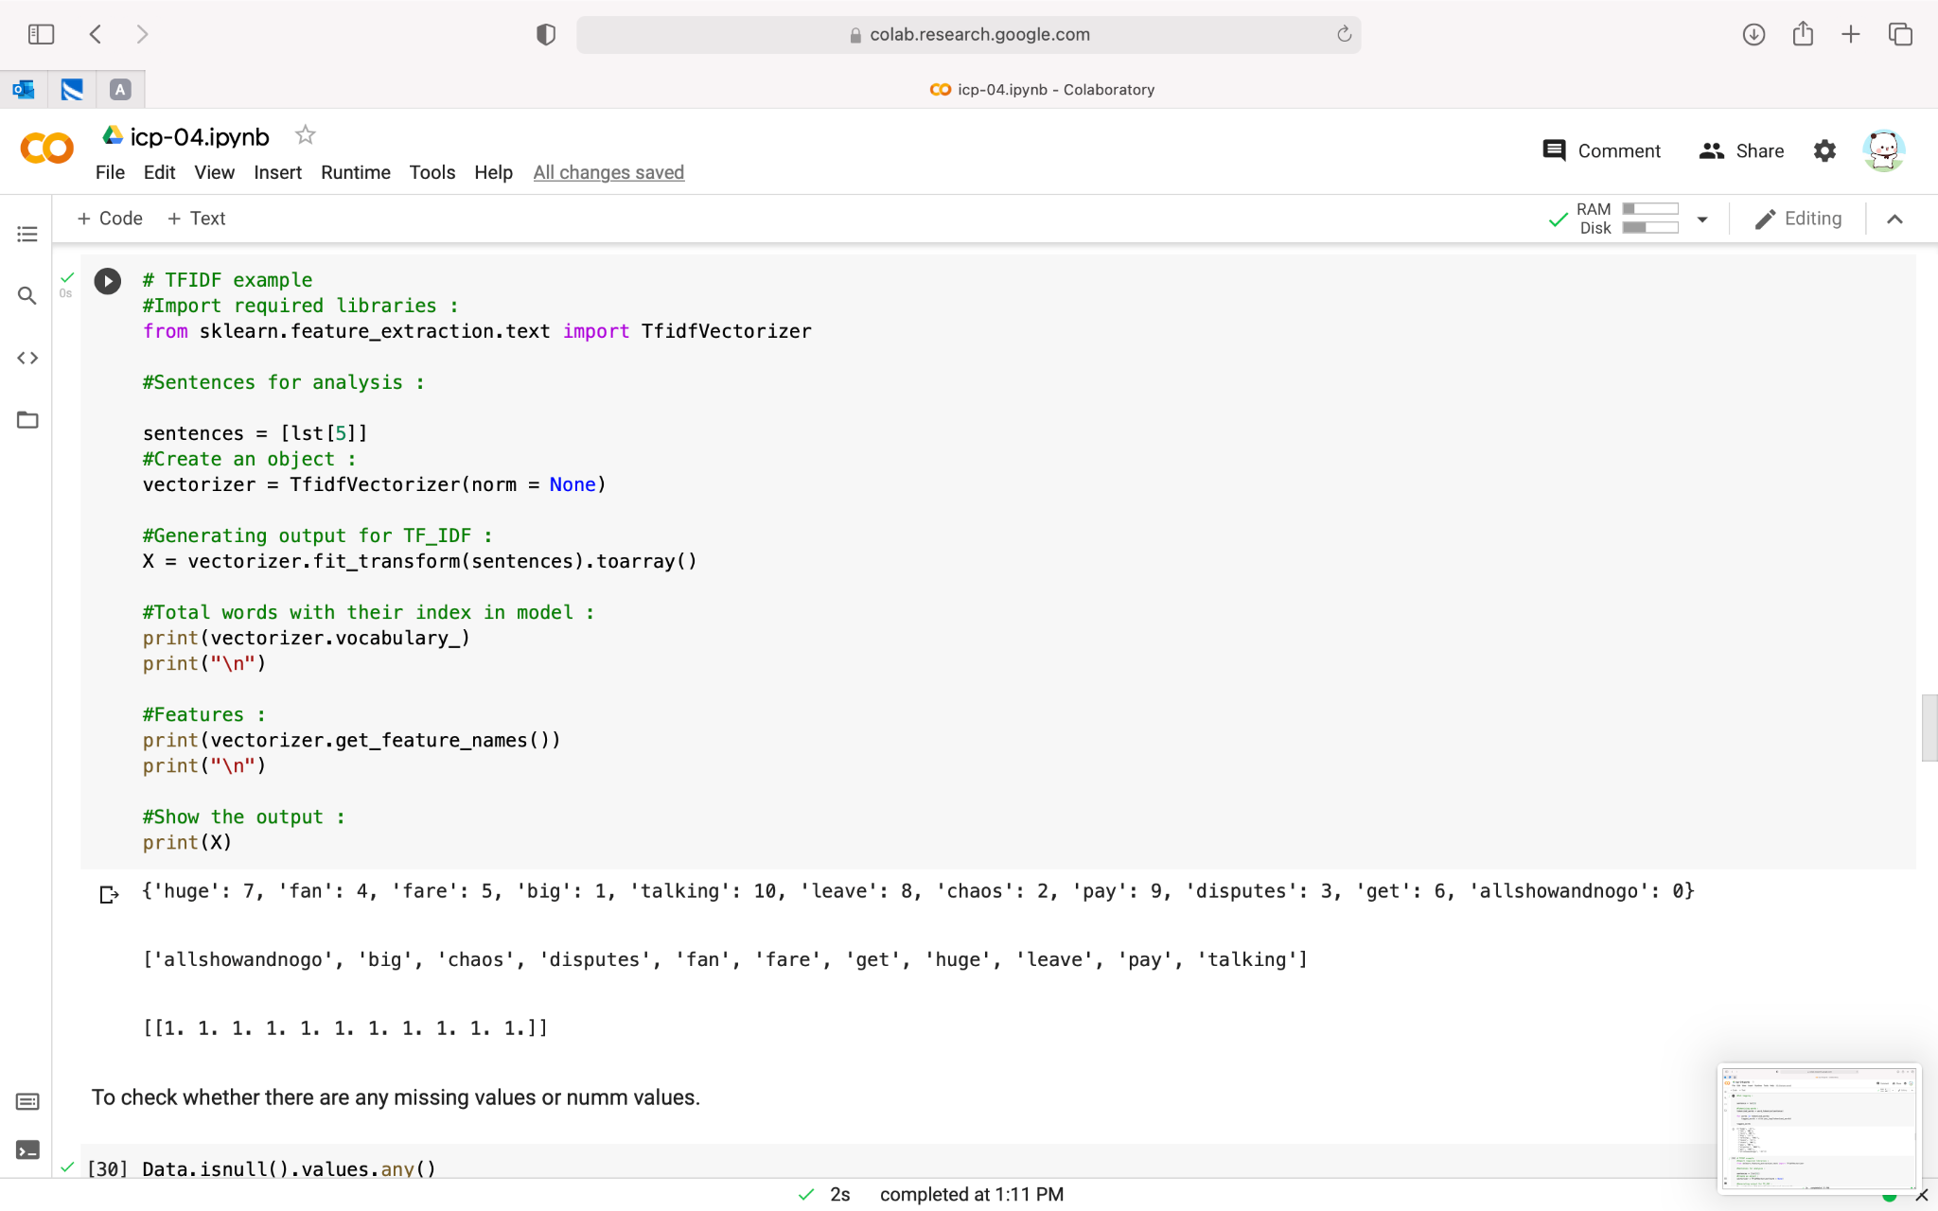

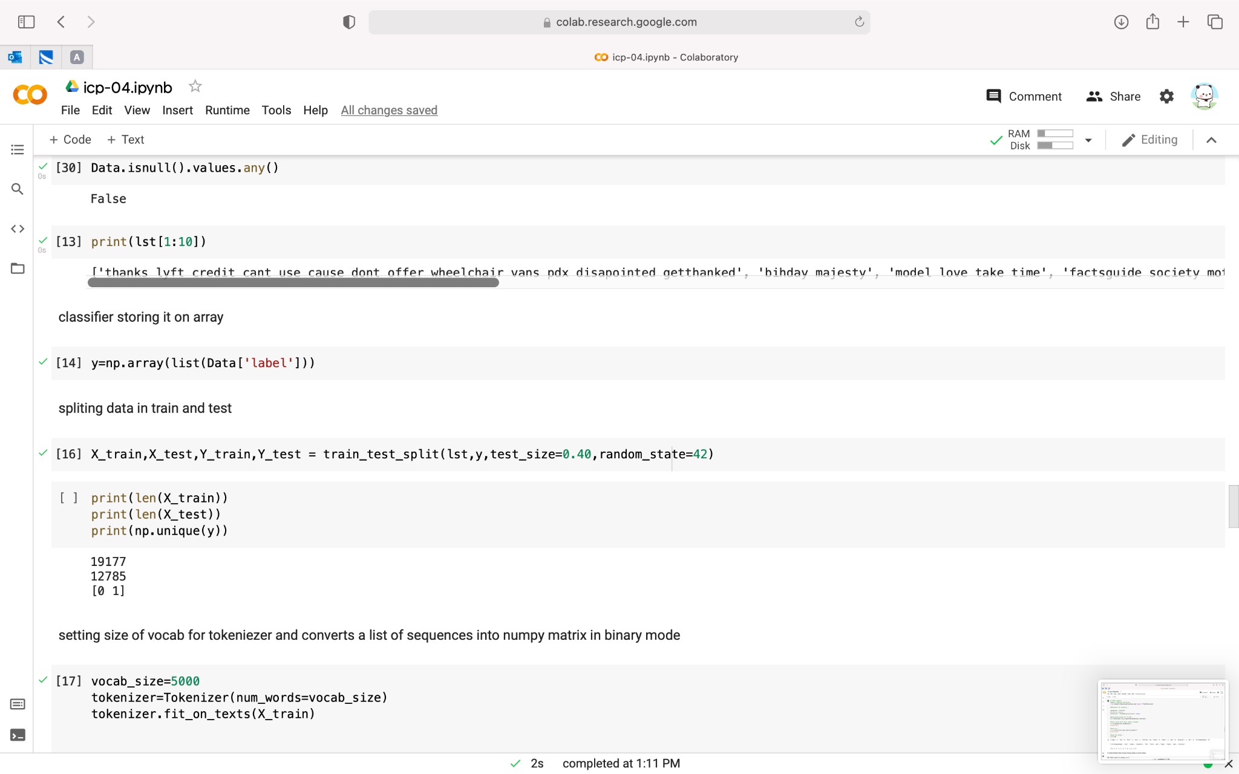

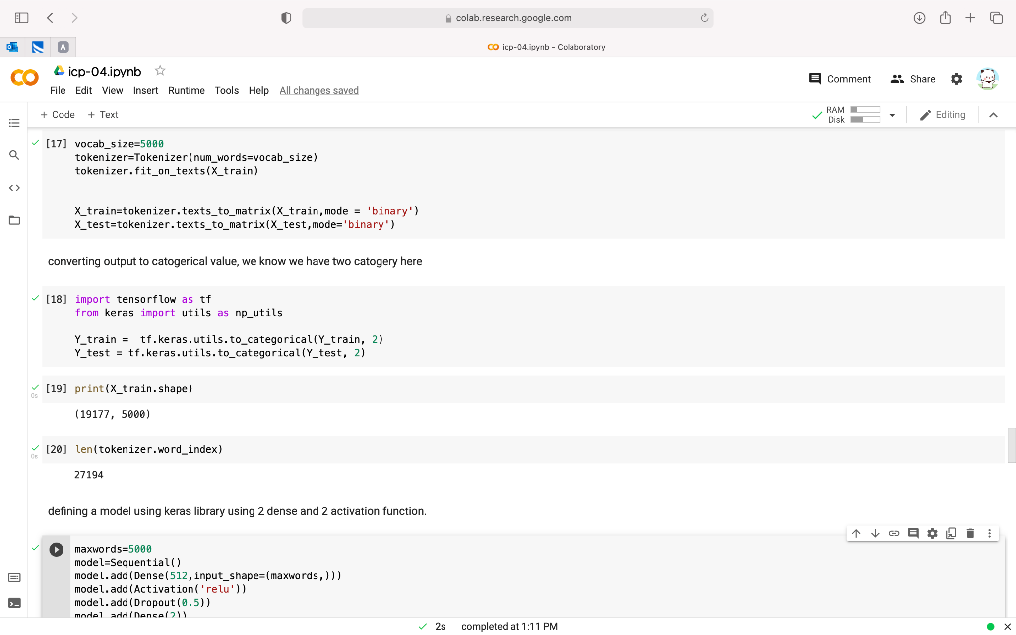

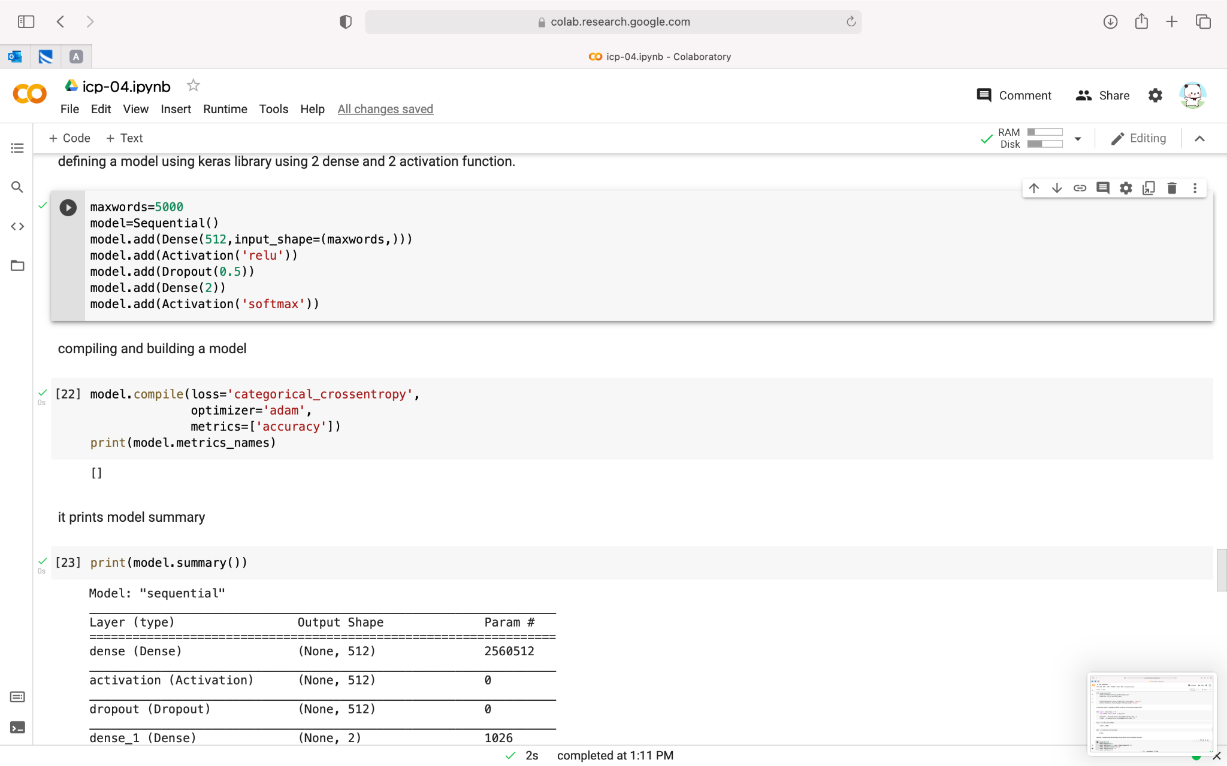

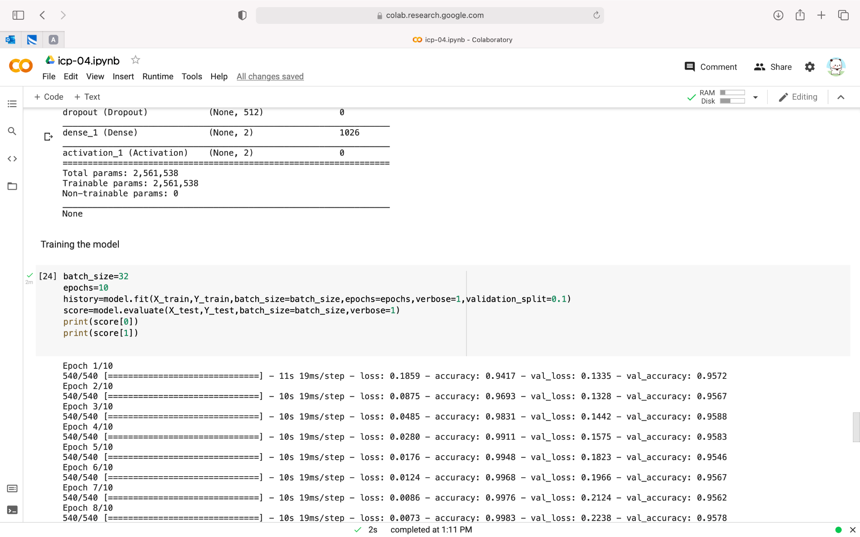

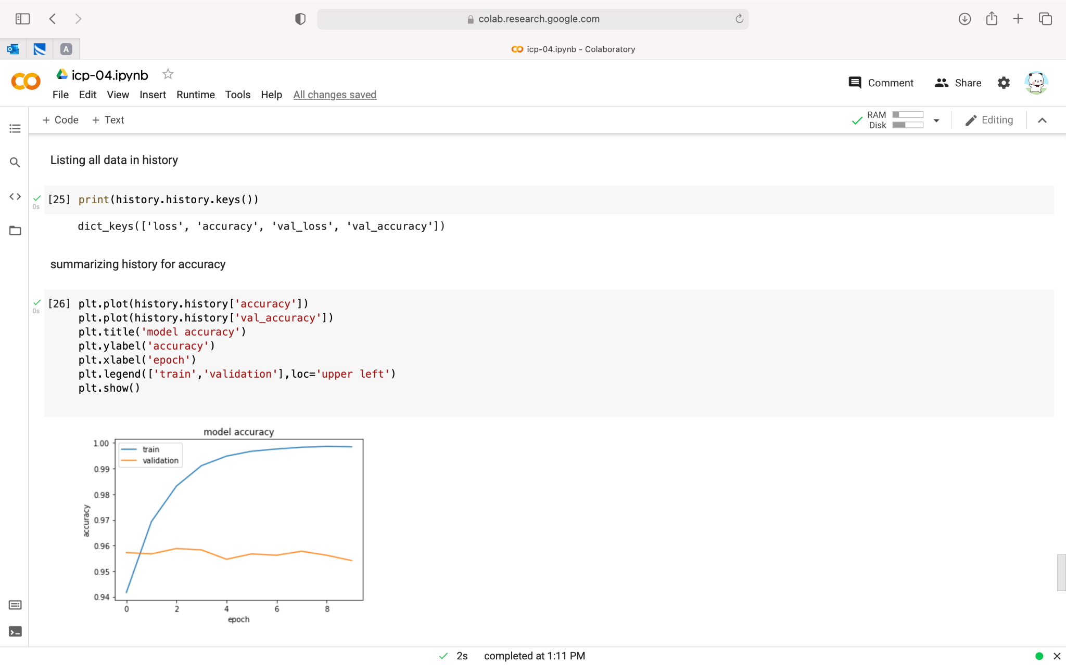

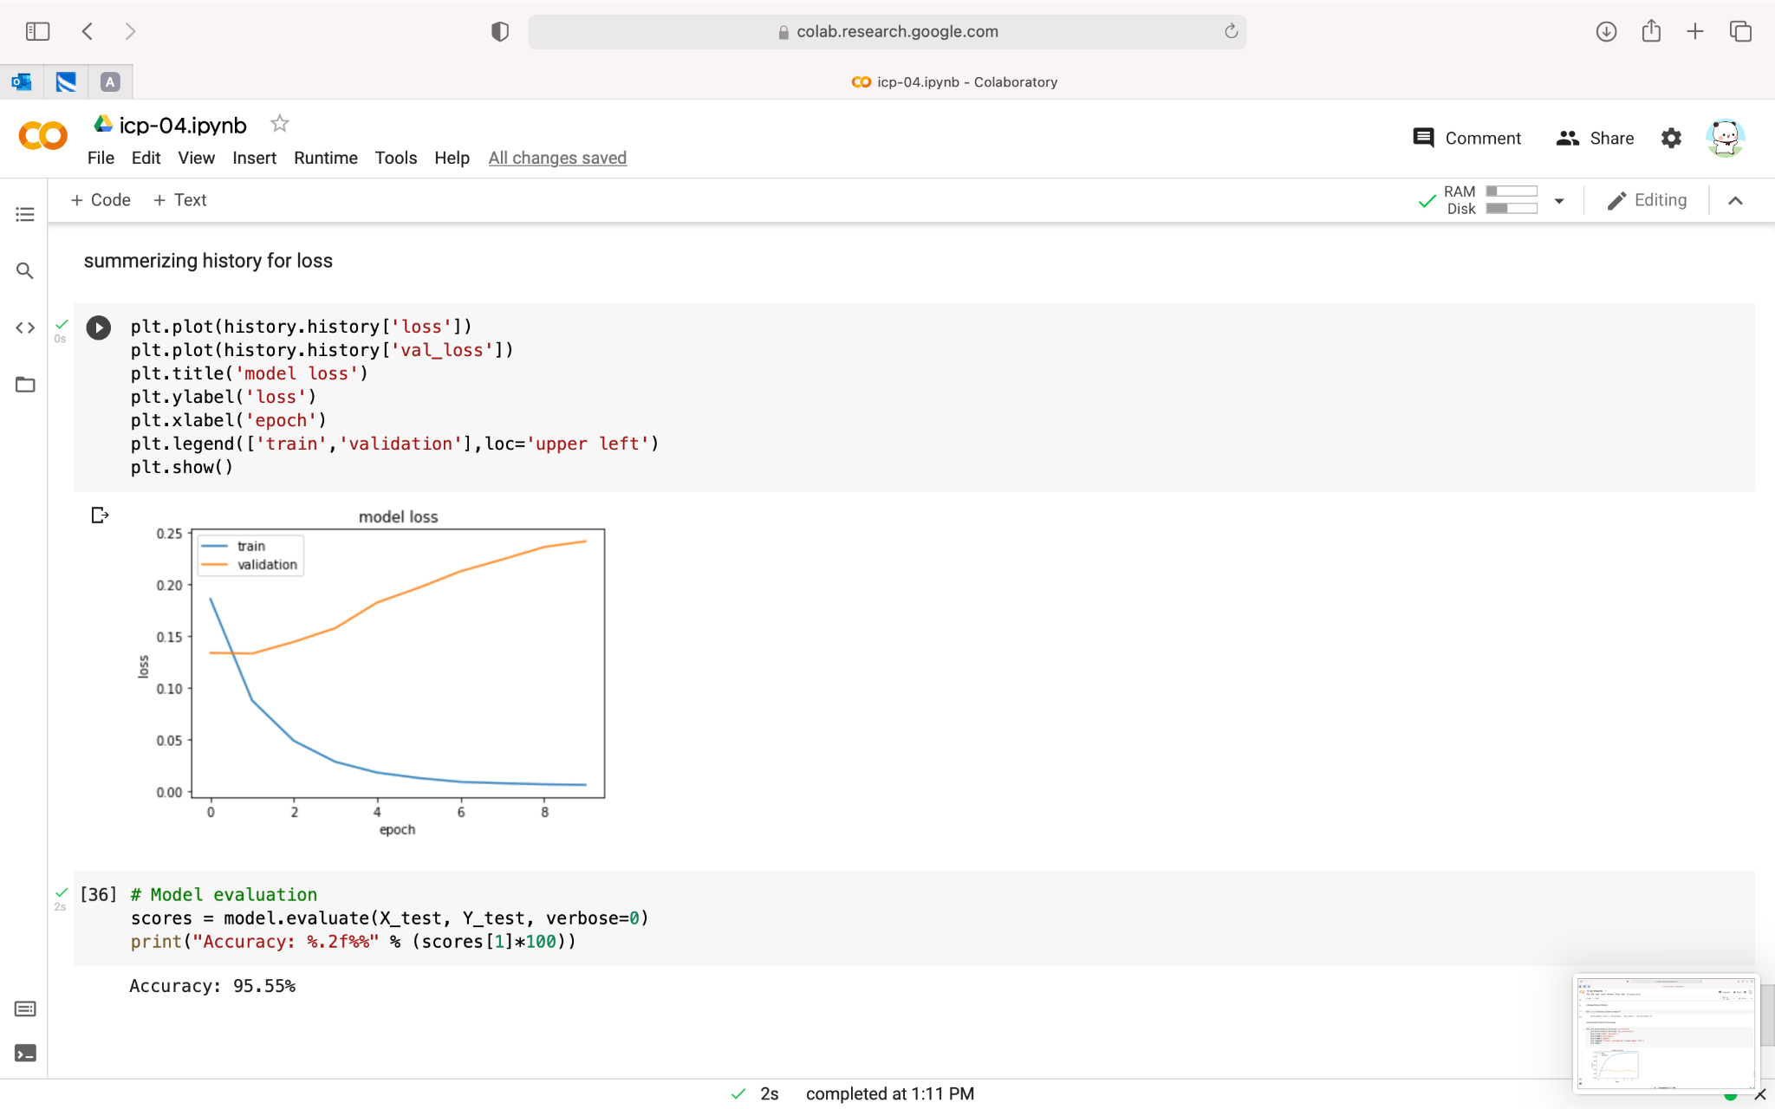

VIDEO LINK:

<https://github.com/saidurga-kanuganti/icp-4/blob/main/Mon%20Sep%2020%202021%2019_05_44.webm>

G) I have learned how to perform sentimental analysis task on the given data using one of the deep learning classifier ie.. keras model for text